**Non-Local means denoising :**

1. **Read our images and convert it into floating point value :**

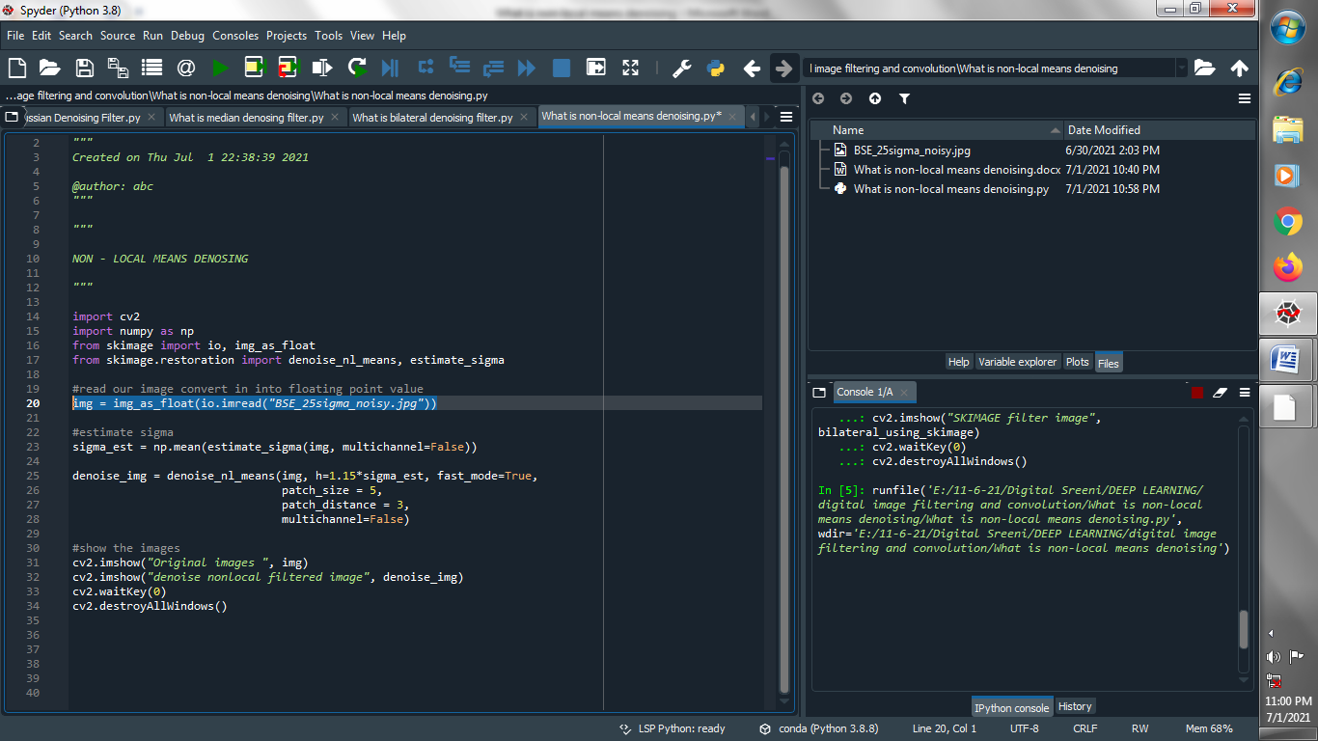

1. **Estimate value of sigma :**

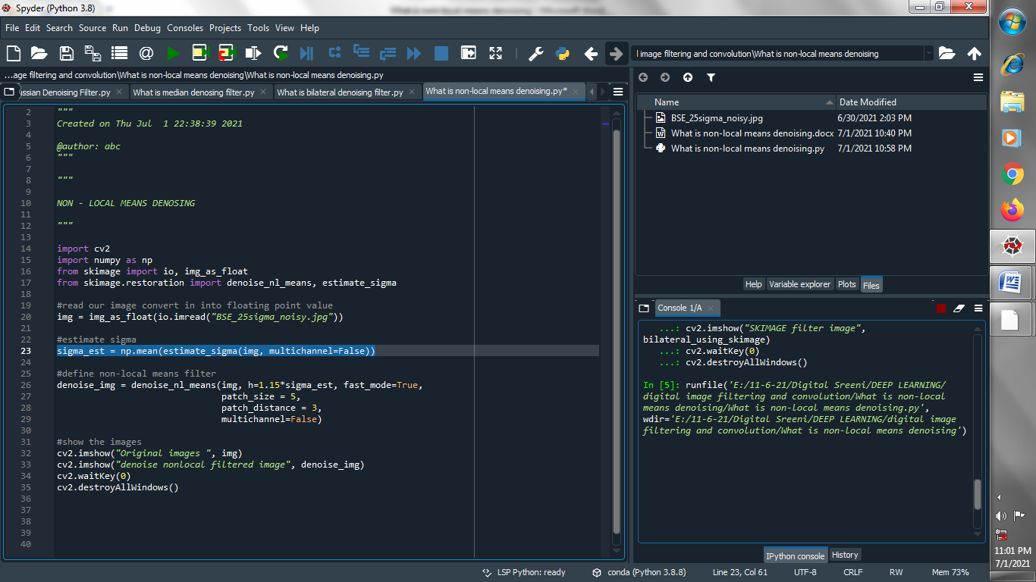

1. **Define non-local means filter :**

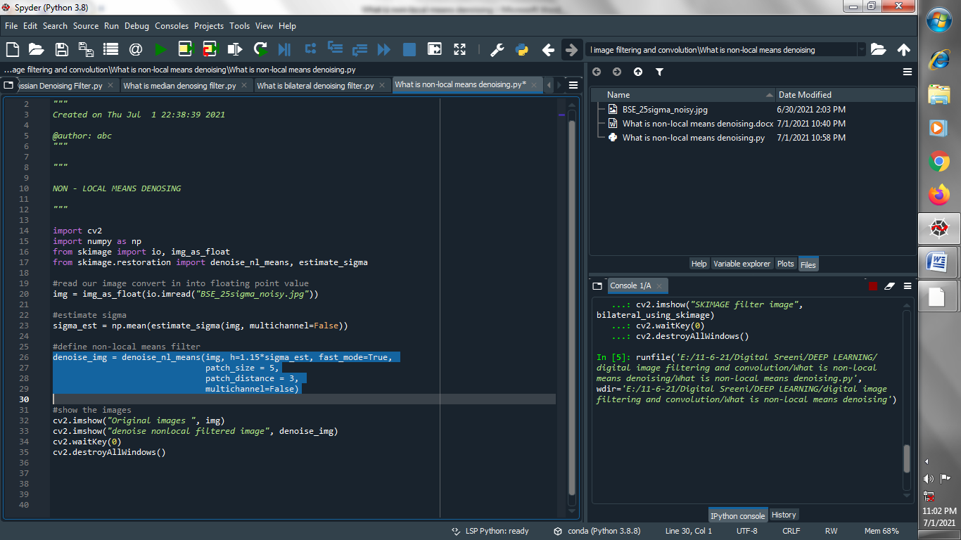

1. **Show the images :**

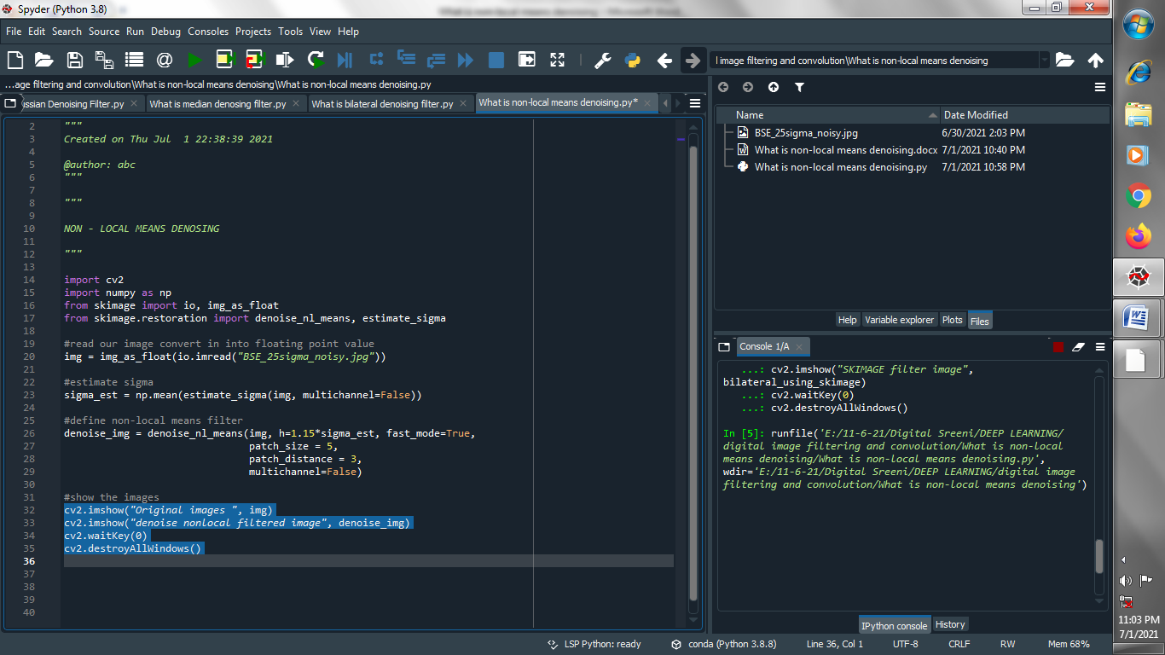

**Output :**

**Original image :**

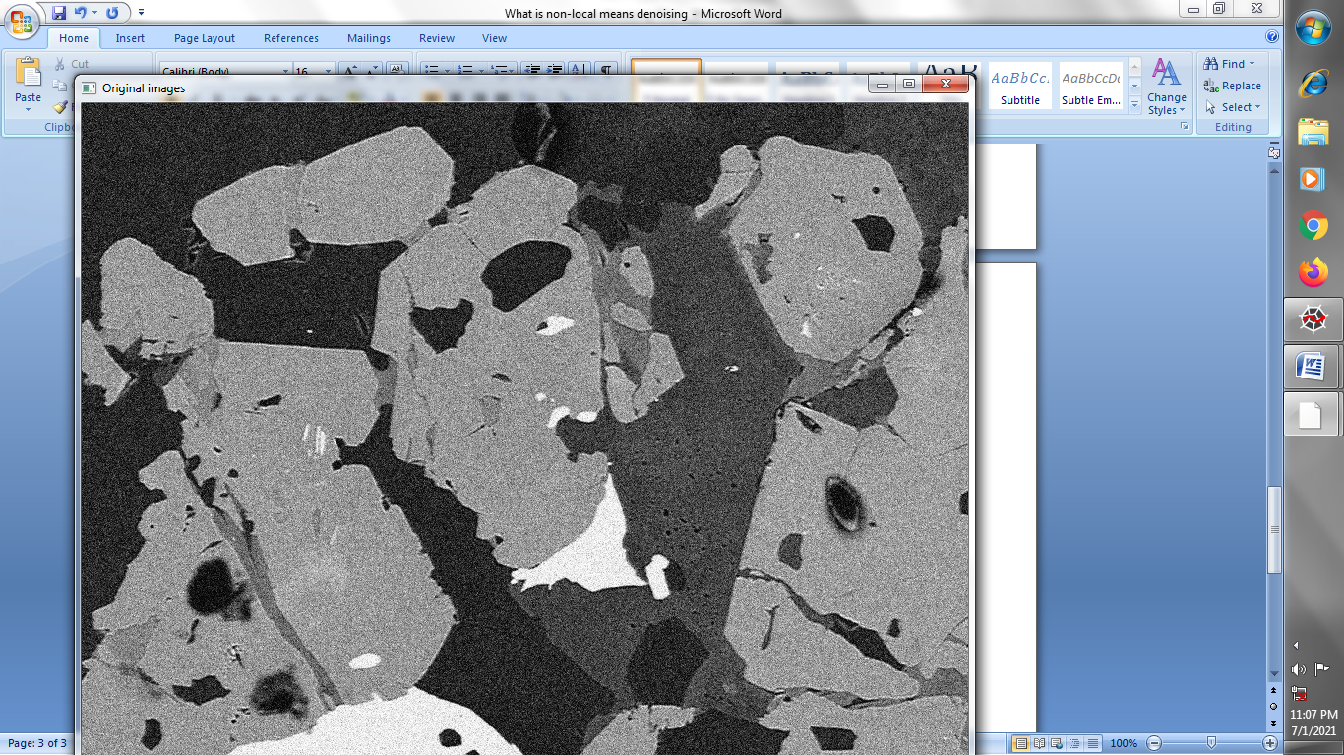

**Non-local filtered image :**

